EUROPEAN TABLE TENNIS UNION

D I R E C T I V E S 2024/2025

v.26.06.2024

The Europe Cup, previously known as the ETTU Cup and the Nancy Evans Cup, hereinafter referred to as “the Event”, shall be organised according to the ETTU Regulations applicable for the Event, i.e. Chapter “K” of the ETTU Handbook.

The following directives provide a supplementary framework to the European Club Competitions Women (ECCW) regulations “K” and must be followed by all participating Clubs.
A club failing to do this shall be fined by the Club Competition Official and eventually made liable for the payment of all documented and undisputed damages claimed by ETTU, or its partners.

The directives may be reviewed and amended in line with the decisions of the ETTU Executive Board to reflect updates to the general organisation and planning of the European Club Competitions Women.

1. PARTIES INVOLVED

● ETTU – European Table Tennis Union, (Secretary General (ETTU/SG)).
● The Clubs participating in the Event.
● The Club Competition Manager.
● The Club Competition Official.
● The sponsors, if any.

2. QUALIFICATION AND REGISTRATION
2.1 The Europe Cup - Women shall be open for the clubs/teams according to the European Club Competition seeding list based on the results of the clubs from the last 3 European Club Competitions’ seasons.
Result points allocation: from the 2021-2022 season 20%, 2022-2023 season 30% and 2023-2024 season 50%.

Points allocation
Champions League winner | 1000
Champions League runner up | 800
Champions League SF | 600
Europe Cup winner | 500
Champions League QF | 400
Europe Cup runner up | 300
Europe Cup SF | 250
Europe Cup QF/CL stage 2 Group 3rd | 200
Europe Trophy Grand Final winner | 190
Europe Trophy Grand Final runner up | 180
Champions League stage 2 Group 4th | 170
Europe Cup R4 | 150
Europe Trophy Grand Final third | 130
Europe Trophy Grand Final participant | 120
Europe Cup R3 | 100
Europe Trophy Regional winner | 90
Europe Trophy Regional runner up | 70
Europe Cup R2 (3rd) | 60
Europe Trophy Regional stage 2 qualifier | 50
Europe Cup R2 (4th) | 40
Europe Trophy Regional stage 1 runner up | 30
Europe Cup R1 (2nd) | 25
Europe Cup R1 (3rd) | 20
Europe Trophy Regional stage 1 participant | 15
Europe Cup R1 (4th) | 10
Europe Cup R1 (5th) | 5

In case of equality in total points for clubs in important positions at the seeding, the most recent result will decide, if equal the result in the previous season, if still equal the result in the season before that. If still equal, a draw by lot will be done.
The Europe Cup winner directly qualifies for the Champions League of the following season.
There is no limitation of teams per national Association for the Europe Cup.
Teams seeded 17-24 can participate in the Champions League but not mandatory i.e. they are not obliged to compete in Champions League group stage 1 and may directly start at Europe Cup group stage 1 or at Europe Trophy (each team seeded 17-24 can decide if start in Champions League or Europe Cup or at Europe Trophy).
If one or more teams seeded 17-24 will not start in the Champions League but in Europe Cup or at Europe Trophy, the next seeded team(s) may take the last positions in Champions League but the total number of teams for the Champions League and Europe Cup together cannot exceed 40.

2.2 Wild cards for up to 4 clubs/teams may be given by ETTU for clubs wishing to join the Europe Cup but not ranked high enough to reach a Europe Cup position by seeding.
Clubs asking for wild cards shall meet the following criteria to be accepted:
- show evidence of their playing venue to meet all directive criteria.
- show evidence (preferably contract) of their top 3 players who will play ECC.
These clubs will be seeded in the last position(s) of the Europe Cup and start in Europe Cup group stage 1.
In case more than 4 clubs ask for a Wild Card and meet all directive criteria, the clubs with the highest total points of their 3 highest ranked players in the most recent World Rankings will have priority.
If free spots remain in the Europe Cup after attribution of the 4 Wild Cards and the confirmation of the seeded teams from the ECC ranking, ETTU may allocate further wild cards to complete the Europe Cup until the maximum participation is reached.
Deadline for a Wild Card application: 16.07.2024 midnight CET
2.3 Deadline for clubs’ team registration: 16.07.2024 midnight CET
The clubs’ team and players registration must be made via the clubs’ National Association
at the ETTU online entry system.
Deadline for players and additional team information including pictures: 15.8.2024 midnight CET.
2.4 Online Registration System:
Wild Card application and all team, player registration and additional team information for the ECC Competition must
be made via the ETTU online registration system by the club`s National Association. ETTU
will publish a registration form which the clubs may fill in and submit to their National
Association for online registration.
2.5 The Clubs concerned shall pay to the ETTU bank account the following entry fee within 7 days upon reception of the final seeding list and invoice:
500€
2.6 Clubs with any debts stemming from ETTU Club competitions (ECCW) will be unable to participate.
Clubs wishing to participate in the ECCW will only be accepted if the entry fees are transferred to the ETTU bank account according to article 2.5.
2.7 If a qualified team does not enter the Europe Cup - Women or does not fulfil the requirements set up, the next highest ranked team of the seeding may fill the vacant position.
2.8 After release of the final seeding list, after the team registration deadline, clubs have 24 hours exit possibility. The clubs and the national Association of the clubs have to notify ETTU about their withdrawal by email. A cancellation fee of two hundred (200) € has to be paid to the ETTU bank account. All withdrawals after the exit possibility will be fined up to five thousand (5.000) €.
2.9 After the deadline for team registration, the clubs and their National Associations will receive the final seeding list with the entered teams.
2.10 After the deadline for players’ registration, the clubs and their National Associations will receive a list with all entered players of the clubs and the clubs and National Associations have 24 hours to inform ETTU in case of any irregularity or mistake. If nothing is notified after this deadline, the players’ list shall be final and no additional player can be accepted.
2.11 All matches shall be played at a venue located within 5 hours from CET.
2.12 Participating clubs and their national Associations are responsible for any
act or failure to act by the club, its players and officials with regards to
finances, behaviour and fair play.
2.13 The competition shall be conducted by the ETTU Secretary General, whose authority shall include changing dates and venues of matches whenever needed.

*in case of an official ball sponsor, the official ball sponsor’s balls shall be used

3 COMPOSITIONS OF TEAMS AND ELIGIBILITY

3.1 Only nominated players are entitled to represent their club/team. After deadline for player registration, no additional player can be accepted for a club/team.
A club/team shall nominate via their National Association 6 – 12 players.
3.2 A club/team can register via their National Association up to 3 non-European* players. In a team match up to 1 non-European* player is entitled to play but either the second or the third non-European* player, if given, can be only nominated as “reserve player” for replacing the other non-European* player.
In case none of the players 1-3 is a non-European* player, the non-European* player being a reserve player may replace either player 1 or player 2.
Up to 2 reserve players per team (including up to 1 non-European* player) can be registered whereof each may replace only one player (either player 1 or player 2) after the second individual match.
3.3. To define player nationality, ETTU will use the nationality as provided by the players’ passports.
3.4. In case a player starts the competition as a non-European* player and her nationality changes during the playing season she shall nonetheless continue to be considered as a non-European* player up to the end of the current playing season.
3.5 A player shall compete only for one team, participating in ETTU club competitions, in the period starting the day before the first round of the competition until the day after the last match in the competition.
That means a player may be registered for more than 1 team, in 1 or more Associations, participating in ETTU Club Competitions but the player shall only be registered for ETTU Club Competitions with 1 team.
The responsibility for player participation in competitions other than the ETTU Club Competitions remains with the national Associations and the clubs themselves.
3.6 A player having signed with a club to play ECCW and refuses to play for that club in ECCW can be suspended for the following ECCW season(s) by ETTU.
3.7 In order to be eligible to compete in the semi-finals and finals, a player shall have at least 2 participations at team matches in the period before (group stages until quarter finals included) i.e. at least participated or having been present in the venue at least at 2 team matches in total. No exception can be made. This eligibility directive also counts for Champions League teams relegated to the Europe Cup.
A player’s presence is only counted if the player is confirmed on the official team line-up sheet (A/B sheet) by the Referee or umpire on duty. On that team line-up sheet all players present in the playing venue before the match starts can be added. Team captains are responsible to check if their players present are written on the team line-up sheet while signing it. No later request will be accepted.
* A non-European player is a player with a nationality outside ETTU member Associations’ countries.

4. PLAYING FORMAT

4.1 The teams seeded 25-40 from the ECC seeding list will play a 1st group stage round with 4 groups of up to 4 teams.
The 4 groups will be played by single round-robin during 2-3 days at 1 location or alternatively at more locations. The teams may apply to host a group on or before the registration deadline and host of each group will be confirmed by ETTU, at ETTU’s discretion.
The group stage 1, 2^{nds}, 3^{rds} and 4^{ths} are relegated to the Europe Trophy.
4.2 The 4 group stage 1 winners proceed to the second group stage together with the 12 Champions League teams from their group stage 1 (2^{nds}, 3^{rds} and 4^{ths}) and will play in 4 groups of 4 teams.
4.3 The 4 groups in stage 2 will be played by single round-robin during 2-3 days at 1 location or alternatively at more locations.
The group stage 2, 3^{rds} and 4^{ths}, except teams already relegated from Champions League to Europe Cup, are relegated to the Europe Trophy.
The 4 group stage 2 winners and the 4 group stage 2 runners-up continue in Round 3.
4.4. Round 3 will be played by home and away matches (double round robin).
Round 3 winners proceed to the quarter finals and compete against the relegated teams from the Champions League (CL Round 2 3^{rds}).
4.5 The quarter finals, semi finals and finals will be played by home and away matches (double round robin).
4.6 The order of play in the group stages:
Round 1 4v2, 3v1
Round 2 1v4, 2v3
Round 3 3v4, 1v2
In case of 1 table, 1v2 shall be the last match played.
For the group matches, a draw will be made by the Referee/umpire 60 minutes prior each team match to define which team is team A and which team is team B. Starting with the 3rd round, the home team will be always considered as the team A, and the away team will be team B.
4.7 In a group, 2 match points shall be awarded for a win, 1 for a loss and 0 for a loss in a not played or unfinished match, and the ranking order shall be determined primarily by the numbers of match points gained.
4.8 If 2 or more teams have gained the same number of match points, their relative positions shall be determined by the results only of matches between them, taking successively the numbers of match points, then the ratio of wins to losses in individual matches, then the ratio of wins to losses in games and then the ratio of wins to losses in points, as far as it is necessary to determine the ranking order.
4.9 If after any step the positions of one or more teams have been determined while others are still equal, the results of matches in which those teams took part shall be excluded from any further calculations needed to resolve the equalities in accordance with the procedure of 4.7 and 4.8.
4.10 If 2 or more teams have gained the same number of match points and have the same ratios of wins to losses in individual matches, games and points, their relative positions shall be decided by lot. The Referee shall do the draw by lot after the end of the team matches with at least the team captains present and inform the ETTU without delay.
4.11 In the final stage (starting with Round 3), each tie will be played in 2 legs, home and away. The home right for the first leg of Round 3 will be given to the 2nd ranked teams of the groups, for the quarter-final, semi-final and final matches the home right for the first leg will be given to the lower ranked team of the seeding list.
The knock-out competition method (starting with Round 3) consists of 2 clubs playing each other where the loser is immediately eliminated from winning the Europe Cup and the winner qualifies to the next round. The 2 clubs play 1 two-legged match - also called “Home and Away” match.
In a “Home and Away” match, the winner is the club with more allocated points than the other one.
Allocation of points is as follows:
a. 3 points for the winner of a 3:0 or 3:1 match,
b. 2 points for the winner of a 3:2 match,
c. 1 point for the loser of a 2:3 match,
d. 0 points for the loser of a 0:3, 1:3 or a walk over match
SPECIAL NOTE:
Team matches in the group stages shall end when a team has won 3 individual matches. Team matches starting with the KO rounds shall end once the winner of that round is defined. If the round’s winner is already defined before a team has won 3 individual matches (of the second leg), playing the following match(es) is optional and at discretion to the 2 clubs. There will be no ETTU Ranking points applied for an individual match played once the winning team of that round is defined.
In a “Home and Away” match, there is a tie between the 2 clubs when each club has the same number of allocated points. In case of a tie, the Golden Match procedure is used. The Golden Match will be started 10 minutes after the away match (2nd leg) is over.
The Golden Match consists of up to 3 games (sets), best of 3. The club winning 2 games (sets) is the winner.
The team captains chose for the Golden Match each 3 players who are according to the directives eligible to play and chose for each player the position 1, 2 and 3. The team captains have to provide their line up for the Golden Match to the Referee within 3 minutes after the regular away match (2nd leg) is over.
There shall be no time out at the Golden Match and no change of ends during a Golden Match game (set).
Regarding the rules concerning discipline (advice, misbehaviour and good presentation) the Golden Match is seen as a continuation of the previous team match.
The order of play in a Golden Match shall be A1 v B1, A2 v B2, A3 v B3. The Golden Match is over once one club has won 2 games (sets).

RESULTS
Leg 1 |  | Leg 2
Team A | Team B | Team A | Team B | Who wins ?
3 | 0 | 0 | 3 | Tie
3 | 1 | 1 | 3 | Tie
3 | 0 | 1 | 3 | Tie
3 | 1 | 0 | 3 | Tie
3 | 2 | 2 | 3 | Tie
3 | 0 | 2 | 3 | Team A
3 | 1 | 2 | 3 | Team A
3 | 2 | 0 | 3 | Team B
3 | 2 | 1 | 3 | Team B

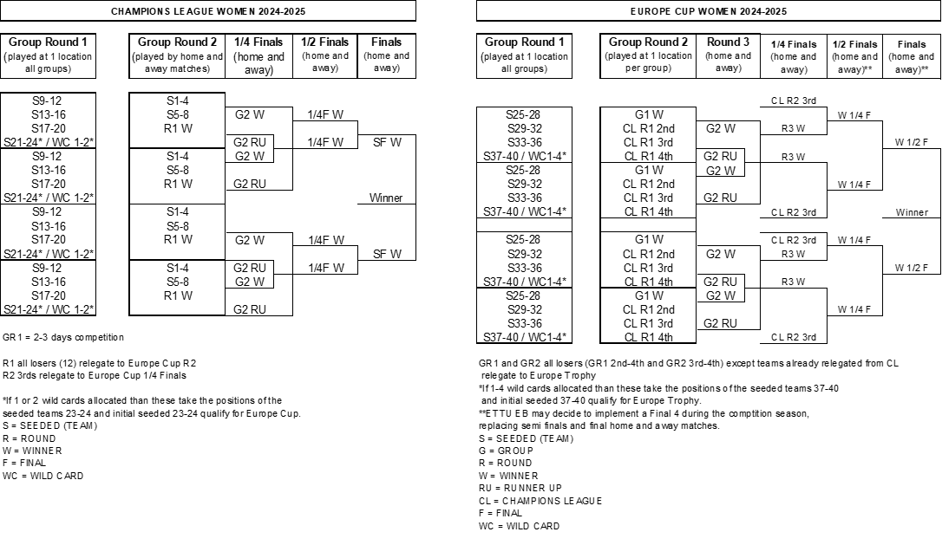

5. PLAYING SYSTEM
5.1 The playing system shall be the New Swaythling Cup system (best of 5 singles) and in each individual match, the 5th game (set) shall start at 0:0 and play until the first player reaches 6 points (sudden death point at 5:5). In the 5th game (set) each player shall serve only once in a row and there will be no change of ends in the 5th game (set).
5.2 A team shall consist of up to 5 players selected from those nominated by the team's club for the event.
It is recommended that a team always arrives at a match with at least 4 eligible players to reduce the risk of walk overs in case player(s) get ill/injured shortly before the match start. When walk overs could have been avoided by the participation of the club’s reserve player, the club may be fined by the Club Competition Official.
This recommendation is based on a requirement for fair play towards the Europe Cup, the opponent club, spectators, media and the Table Tennis sport.
A team will lose by walk over (WO) in case the team has less than 2 players ready to play.
5.3 All individual matches (singles) of a same team match shall be played on the same table.
5.4 The home team considered to be composed by the players A1, A2, A3 and the visiting team considered to be composed by the players B1, B2, B3. In the group stages (played at 1 location) a draw will be made by the Referee or umpire on duty to define which team is A and B.
In the group stages (played at 1 location) a draw will be made by the Referee or umpire on duty to define which team is A and B. The order of play in a team match shall be A1 v B2, A2 v B1, A3 v B3, A1 v B1, A2 v B2, and the match shall end when a team has won 3 singles, each the best of 5 games.
After the second single in a team match, player No. 4 or No. 5 of the team may replace player A1 or A2 (for the home team) respectively player B1 or B2 (for the away team). In a team match up to 1 non-European* player is entitled to play but either the second or the third non-European* player, if given, can be only nominated as “reserve player” for replacing the other non-European* player. In case none of the players 1-3 is a non-European* player, the non-European* player being a reserve player may replace either player 1 or player 2.
Up to 2 reserve players per team (including up to 1 non-European* player) can be registered whereof each may replace only one player (either player 1 or player 2) after the second individual match.
Such player substitution must be announced by the respective team captain to the Referee at the latest before the start of the third single.
5.5 Intervals between individual matches shall not exceed 1 minute except for the interval after the second individual match, where maximum a 15-minute break is accepted. For the group stage matches, there shall be no delay, only if written acceptance by ETTU.
The home team shall inform the visiting team, ETTU and the Referee 1 week prior the match about the interval planned after the second individual match.
At each time-out and between each game, the umpire shall place the Time-Out-Clock on the table in the main camera direction (if available).

5.6 MULTI BALLS AND BALL BOYS AND GIRLS (BBGs)
Mandatory starting from the quarter finals:
The host club has to put on disposal before the match starts 40 balls and the
2 team captains shall choose 30 balls (15 balls each).
In each match 30 balls shall be kept by the umpire who will provide after each point a new ball to the serving player, in case the ball used from the previous rally is not in imminent reach of 1 of the 2 players. Balls remaining in the Field of Play (FoP) will be collected after each rally by ball boys/girls (BBGs) organised by the home club. 2 BBGs shall sit behind the corner board (1 on each long side, places marked “x” on below diagram). BBGs watch the playing field and collect the balls from the floor, and then run back to their zones. BBGs collecting balls should only move in designated areas (marked “→” on below diagram). BBGs have to return the balls to the umpire after each game, during time outs and when the umpire runs out of balls.
Delivery of the balls to the umpire may occur at any time after a distinct signal from the umpire to the BBGs.
Balls leaving the FoP will not be collected during a game.
BBGs move only according to “→” on below diagram to hand over the balls to the umpire.
BBGs shall be dressed in sportswear, preferably similar clothing.
There is no age limit for BBGs, however BBGs shall be mentally and physically able to be fully concentrated and collect balls quickly.
BBGs shall behave and act neutral.
Before the service, players receive the balls from the assistant umpire.
After the rally, players do not collect the balls from the FoP, they continue the game, unless the rally ends in imminent reach of 1 of the 2 players, players can reuse that ball for the next rally.
There shall be 1 chair in each of the x marked boxes so that BBGs do not disrupt the matches.
Up to 10 seconds after the previous rally finished, except for toweling after every 6 points from the start of each game, the serving player has to start the next rally and the receiver has to be ready as well.
The clubs are recommended to make a training session with the BBGs.
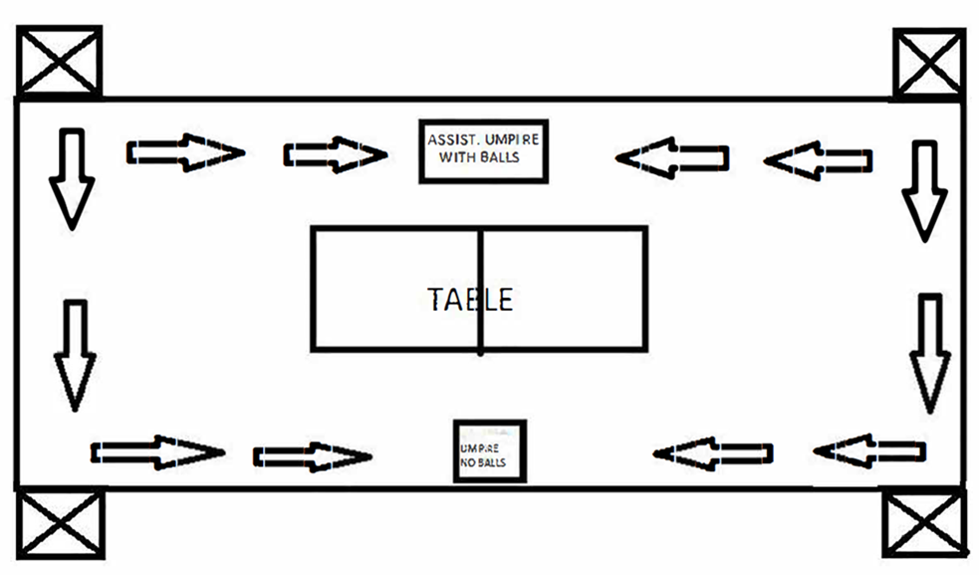
Playing field with designated zones for BBGs.

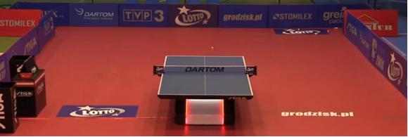
Example show court with BBGs zones

6. THE DRAW
6.1 The draw shall be made in public by the ETTU on a date and a place to be published in advance on the official ETTU web site.
6.2 The draw will be made according to the final seeding list.
Group stage 1:
The teams seeded 25-40 will play a 1st group stage round with 4 groups of up to 4 teams.
The 4 highest seeded teams shall be drawn at positions 1, the next 4 seeded shall be drawn at positions 2 etc.
Teams appointed to host a group round may be drawn first in order to secure that every group has a host.
Teams from the same national Association shall, as far as possible, be drawn into different groups.
Group stage 2:
The 4 group stage 1 winners shall be drawn on positions 1 in group stage 2.
The relegated Champions League teams from CL group stage 1 (CL R1 2^{nds}) shall be drawn into positions 2, CL R1 3^{rds} into positions 3 and CL R1 4^{ths} into positions 4.
Teams appointed to host a group round may be drawn first in order to secure that every group has a host.
The relegated Champions League teams coming from the same group shall be drawn into different groups in Europe Cup group stage 2. (first priority).
Teams from the same national Association shall, as far as possible, be drawn into different groups (second priority).

Final rounds:
The draw for the final stage (starting with Round 3) will be made after completion of group stage 2.
The group stage 2 winners will be drawn against the runners-up so that a group winner and group runner-up from the same group cannot meet in the third round. A group winner and group runner-up from the same group may meet in the semifinal or final. There will be no separation by Association for the final stage.
For the quarter finals, the 4 relegated Champions League teams (CL Round 2 3^{rds}) will be freely drawn on the 4 positions to compete against the Europe Cup Round 3 winners.

ETTU will confirm before each draw the draw procedure and has the authority to adapt the procedure and system as necessary.

7. FIXTURES
7.1 The competition shall be held each season according to a schedule published by ETTU.
7.2 The actual playing season shall be from the day before the first round of the competition until the day after the second final match.
7.3 In the first two stages, group matches shall be played preferably as follows:

Group with 4 teams:

Round 1 4v2, 3v1
Round 2 1v4, 2v3
Round 3 3v4, 1v2

In case a group is played on 1 table, 1v2 shall be the last match played.

Group with 3 teams.
Round 1 (3v1)
Round 2 (2v3)
Round 3 (1v2)

7.4 Each team, starting with the Round 3 matches, decides about their home matches dates and starting times. Starting with Round 3 all qualified teams must confirm their home matches to ETTU within 3 days following the completion of the previous stage/round.
Matches shall be only scheduled within the given period for each stage/round by ETTU. Any variation to that period must be approved in writing by ETTU.
7.5 The home club must send to the visiting club(s) a written invitation including information about the training sessions and the “daily schedule/programme”, to arrive without delay*, giving details of the location, date, starting time and accommodation possibilities, the brands and colours of tables and balls which will be used in the match, and shall send a copy of this invitation to the Club Competition Manager club@ettu.org by email.
Clubs having players needing a special invitation to obtain visa to travel to different countries must inform the opponent club immediately and the home club has to provide them with such an invitation letter needed. The home club however is not obliged to send such invitation letters by post to a country outside Europe.
7.6 Europe Cup competition dates:

GS1: 15-17.11.2024
GS2: 13-15.12.2024
R3 leg1, leg2: TBC 2025
QF1, QF2 : TBC 2025
SF1, SF2: TBC 2025
F1, F2: TBC 2025)

The dates are subject to change by ETTU in case of any major change at the international TT calendar.

8. COMPETITION HALLS, EQUIPMENT AND PLAYING CONDITIONS
8.1 There shall be a playing hall, with preferably a seating capacity of minimum 200 and which is large enough to accommodate one (1) playing court (table), in a playing area of at least 14 m long, 7 m wide and 4 m high.
For the group stages, there shall be preferably 4 playing courts with training tables
8.2 The home club has to put on disposal to their guest clubs a bench or chairs behind the playing court for 8 persons. Neither the home club nor the guest club can have more than 8 persons there.
8.3 All matches shall be played on ITTF approved floor mats.
8.4 The light intensity shall not be less than 800 LUX over the table.
8.5 The temperature in the playing area shall be between 18° C and 25° C.
8.6 Each club shall notify ETTU the brands and colours of the table, net assembly and ball*, together with the colour of the playing clothing (2 sets of shirts).
8.7 Starting with the 3rd round, the home club shall notify the visiting club of the colours of its playing clothing and the visiting team shall wear different colours.
For the group stage matches, teams shall bring 2 sets of playing clothing (shirts), with a clear difference in the main colour, to use for the matches. In case 2 teams wish to use a shirt with no clear difference in colour and if there is no agreement between the teams, the Referee or umpire will draw the shirt to be used for each team by lot.
8.8 The ECCW opts out from ITTF Regulations for International Competitions for advertisements on players’ clothing to allow more space on clothing for advertisement.
Opting out is only for the sizes and total number of advertisements.
8.9 For all competition matches only A-boards or B-boards or LED-panels must be used. No use of classic surrounds
8.10 LED-panels are allowed provided they comply with the ITTF regulation.
8.11 Background shall be kept dark.
8.12 The playing conditions must be checked by the Referee. Even in case of disputes about the playing conditions the clubs are obliged to play the match.
8.13 There shall be sufficient changing rooms (at least 3, 1 for each of the teams and 1 for the referee/umpires) of good standard.
8.14 Matches shall start at the designated time without delay.
8.15 Each club participating in the ECCW is recommended to have a Time-Out-Clock and shall provide it for the Referee at least 60 minutes before the match starts.
8.16 Home clubs must guarantee their guest clubs starting from the KO stage on at least 10% of the seating capacity for spectators and upon request provide in advance information on purchasing prize. (unless force majeure restriction).

*in case of an official ball sponsor, the official ball sponsor’s balls shall be used

9. HYGIENIC GUIDELINES
9.1 Participants arriving are obliged to follow the host’s national and local hygienic guidelines and regulations.

9.2 If participants are reported to not comply with the host’s national and local hygienic guidelines and regulations, they may be withdrawn from the competition and the respective team may in addition be financially sanctioned by ETTU.
10. PRACTICE
Practice shall be arranged for the visiting teams under the same conditions as for the home team with the same equipment as used during the match.

11. RESULTS
Immediately after a match the Referee shall send by e-mail to result@ettu.org, press@ettu.org and urc@ettu.org a scanned copy of the results sheet and a scanned copy of the team line up (A/B) sheet.

12. ACCOMMODATION / HOSPITALITY / TRANSPORTATION / MEALS / VISAS
12.1 For the team matches with 1 guest club:

The host club shall propose to their guest club, a hotel of good standard (minimum 3 stars) and inform them about the room rates which shall not be higher than the official rate of the hotel, and the hotel’s website link, without delay*. In case the away club does not agree on the proposal, the away team is free to choose another hotel, and shall inform about their decision without delay*. Booking and payment of the hotel is the obligation of the away club. The transport from and to the local airport or from and to the railway station (host club to decide if transport from and to the airport or from and to the railway station) to the hotel or to the playing hall and back must be provided free of charge by the home club. If the visiting club delegation arrives / departs at different times / days where more than 1 transportation is needed, or if the delegation of a visiting team is superior to 5 and therefore more than 1 transportation is needed, then the visiting club shall reimburse the cost to the host for the additional transport(s). The costs of additional transport shall be confirmed by the host to the visiting clubs without delay*. If the away team choses another hotel than the one proposed by the host team, transportation (including transportation from the hotel to the playing venue and from the playing venue to the hotel) must be only taken over by the home team if the hotel’s distance to the playing hall is not more than 5 km further away than the proposed hotel from the playing hall.

The host shall send to their guest club a proposal of meals and the costs, without delay*.
Guest clubs shall then inform the host club without delay* with their decision on meals (accepting the offer or arranging for own meals).

For the team matches with more than 1 guest club:
The same directive as laid down for the team matches with 1 club except that the host club shall make a complete hospitality package offer to their guest clubs and shall only guarantee transportation to the guest clubs in case the official package is used.

The Referee and umpires have to inform the host club without delay about their accommodation needs. The host club shall book and take over the costs and shall arrange for their travel from and to the local airport or from and to the railway station to the hotel or to the playing hall and back, free of charge, and provide the umpire team with meals, free of charge.

For the matches, the host club shall provide free hospitality and transportation from and to the playing venue and from and to the airport and railway station for up to 2 days and nights for up to 3 ETTU/ partner representatives, representatives, if requested.
For the second leg final, the host club shall provide free hospitality up to 2 days and nights for up to 5 ETTU/ partner representatives. Participating clubs must provide for their respective venue a minimum of six (6) accreditations for ETTU operators and partners.
The home club shall provide one main contact for organisational matters to the visiting club in order to arrange everything smoothly. This “team manager” shall be fluently speaking English.

Starting with the KO stage, the host team shall prepare an agenda for the visiting team including transport from the airport / station which shall be sent within one week after reception of the arrival time / date of the visiting team to all parties involved.

The host club has to send to their guest club without delay* an invitation letter including all needed details so that the delegation of the guest club is able to receive their visas (if needed) in due time. The costs for sending these invitations is at the home club’s expense unless the guest club requests sending a letter by postal mail to a country outside Europe, than the guest club has to reimburse the home club the costs for the sending.

13. REFEREES AND UMPIRES
13.1 For the Round 3 and quarter-final matches, the National Association of the home club shall propose at least three umpires.
At least one of these umpires shall preferably be an International Umpire and shall fulfil the duties of the Referee.
For the group stage 1 and group stage 2, 2 umpires per competition table shall be nominated by the ETTU URC together with 1 Referee.
13.2 For the semifinal and final matches the ETTU URC shall arrange for two International Umpires coming from an Association other than those of the clubs whose teams are involved in the respective match. One of these International Umpires shall fulfil the duties of the Referee. The Association of the home club shall provide International or National Umpires to perform the duties of assistant umpires.
If foreign International Umpires are not available for a match, the ETTU URC may nominate an umpire team from the same Association as the home club.
For the semi-finals, one of the foreign umpires shall preferably be an International Referee or International Umpire – Blue Badge and for the finals, both umpires shall preferably be International Referee or International Umpire – Blue Badge.
13.3 In emergency cases, other umpires present at the match may replace the missing nominated umpires, one of them taking over the duty as Referee. The host shall contact ETTU and ETTU must approve the “emergency umpire team”.
13.4 The umpires appointed by the ETTU shall receive free hospitality (every umpire is entitled for a single room and full board / meals), a daily allowance as defined below and shall also get their travel expenses reimbursed by the home club (by economy class train or plane, or by car at 40 eurocents per km plus eventual “vignette” costs, and visa costs) shall be reimbursed by the home club either by bank transfer before the match or latest in cash upon arrival.
Daily allowance:
Referee: 100 euros
Blue Badge: 100 euros
White Badge: 60 euros
National Umpire: 40 euros
13.5 The nominated umpires have to arrange their travel to and from the playing hall / airport / railway station as soon as their nomination is received and to inform the home club without delay. The nominated umpires shall use the most economic transport (car, train or flight).
13.6 The appointed Referee has the following responsibilities:
- conduct the team match
- avoid early and late match start (punctual start)
- collect the team line up from both team captains latest 40 minutes before the first match starts
- send the team line up (match order of play/pairings) latest 30 minutes before the first match starts to the mail addresses as communicated to the Referee.
- send the scanned score sheet and team line up right after completion of the team match as defined under article 11.
- to inform ETTU and its partners without delay if there is any player replacement after the second individual match.

In case of any changes on short notice (such as injuries, breaks, delays, etc.) the Referee shall also send an email with any known information as soon as possible.

14. GENERAL COMMUNICATION
To guarantee a smooth running of the Europe Cup Women, all participating clubs must reply to all organisational and communication requests from ETTU latest within 48 hours. Every club must appoint one contact person who is fluent in English.

15. MEDIA AND MARKETING
15.1 The ETTU holds the following rights for every team match within the ECCW:
15.1.1
- -any kind of Television transmission
- -Internet Broadband Streaming
- -IPTV and Data & Scoring Rights (live, delayed and excerpts)
- -Mobile devices rights and Radio rights
- -the event’s marketing and equipment rights
- -world wide exclusive betting rights

15.2 Every club in the European Club Competition- Women (ECCW) has to fulfil the obligations regarding the production of live streaming. Therefore, every club has to provide a dedicated Internet connection with a minimum UPLOAD bandwidth of 100 Megabit/sec.
Further details are laid down under item 16.
15.3 The live ticker will be operated by the umpires on duty. The host team must provide with LAN internet connection and power supply at the umpire table(s)/chair(s).

15.4 CLUBS - ORGANISERS
The clubs are responsible to organise and host all of their home matches. Thus, the home club is the “organiser” of all of its home matches.
Unauthorised streams (e.g. from TV broadcasters, production companies, spectators using their mobile phones, etc.) as well as unauthorised tickering must be stopped by the organisers (pre-announced production teams are also allowed to stop unauthorised streaming and tickering). Organisers must also inform their supporters about this fact.

15.5 PROMOTIONAL ACTIVITIES
It is recommended to invite local press to the game and get free access to all relevant areas of the competition hall. A convenient number of seats to be arranged for the journalists along the court. These seats to be equipped with tables and power sockets.
Each participating club must co-operate with the ETTU social media manager to promote the competition.

15.6 PHOTOGRAPHS AND PRESS
Participating clubs must provide with the requested photographs at the time of the online registration (team, players etc), with requested photographs immediately after the end of a team match (host team obligation), with quotes from the team manager and players before and after a team match as requested by the ETTU Press manager.

15.7 OFFICIAL MATCH PROTOCOL
The organisers (home teams) are responsible for the preparation and smooth running of their home matches.
The Official Match Protocol must be implemented and respected by all the participants.
Additional note: at European Club Competitions, no national anthems shall be displayed, nor country flags being hoisted.

15.8 PLAYING CLOTHING
The ECCW opts out from ITTF Regulations for International Competitions for advertisements on players’ clothing to allow more space on clothing for advertisement.
Opting out is only for the sizes and total number of advertisements.
The use / choice of shirts to use is defined in directive 8.6 and 8.7.

15.9 MARKETING / BRANDING
In case ETTU confirms a title sponsor of the Europe Cup, the naming is (name of the sponsor)-Europe Cup women. Each participating club should in any publication use the correct name.

Each host shall have the following marketing obligations in addition to the online stream as described in 16:

For each home match to produce on its own cost 1 ETTU/competition A-board or B-board with the ETTU logo to be displayed at a surround visible at the main camera view.
In case of LED-panels, the ETTU will make available the graphic of the ETTU logo to be displayed.
To accept additional advertisement space for the title sponsor (only in case of a confirmed title sponsor) but at no cost for the host.

For the 2nd final match, the host team must produce on its own cost a backdrop with the title sponsor (if any), ETTU and host club’s sponsors logos for interviews and for the award ceremony. Backdrop dimensions: 4m length x 2,2m height.
The host for the 2nd final match must also produce on its own cost an ETTU floor sticker to be displayed on the floor of the field of play next to the table. The financial contribution to the host of the final (second leg) is 1000€.

The financial contribution for the host in group stage 1, in case of hosting all 4 groups is 1000€.
The financial contribution for the host in group stage 2, in case of hosting all 4 groups is 1000€.

16. INTERNET - STREAMING
Every host club has to produce online streaming of its matches according to the ETTU streaming technical requirements which includes an internet connection with a minimum dedicated UPLOAD bandwidth of 100 megabit/sec

Reference how the main camera shall be placed:
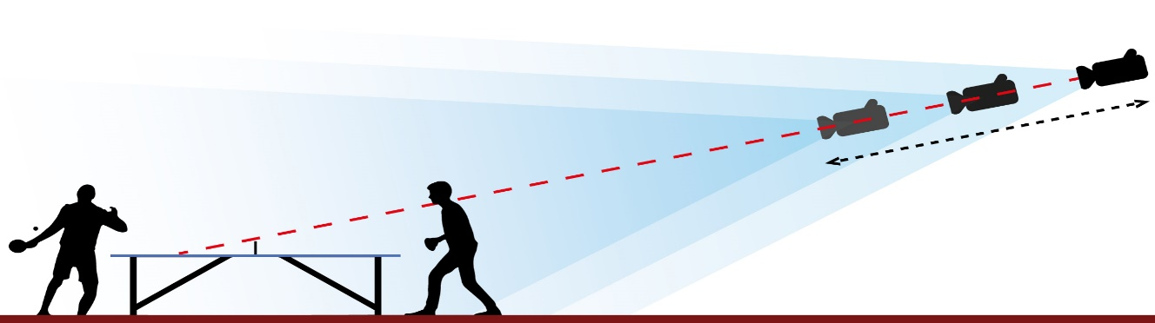

This figure acts as an example. It is mandatory that the camera is positioned in a way that the backside of the table is visible.
The Referee shall send the team line up etc according to directive 13.6.

17. ENTRY CARDS / VIP
If requested, the Organising Club shall provide ETTU with five (5) VIP entry tickets (free of charge) for ETTU representatives, their guests, partners, sponsors, suppliers, etc.

18. VIP CARE
There shall preferably be a special VIP-room, where drinks and snacks are served to honorary guests, sponsors, suppliers, etc., free of charge.

19. WINNER’S CEREMONY
There shall be a winner’s ceremony at the end of the Final (second leg). with a podium or arrangement (for 14 persons) according to the ETTU award ceremony script.

20. TROPHIES and AWARDS
After the 2nd final match, the winner shall receive the appropriate trophy, the winner and the runner-up shall receive medals by ETTU.
ETTU will pay out a prize money of 8.000€ in total. The distribution of the prize money is as follows: 4.000€ for the winner, 2.500€ for the runner up and 750€ for each losing semi finalist.

21. FINANCIAL CONDITIONS
21.1 The entry fee shall be paid according to Directive 2.5.

22. PRIVACY POLICY
By registering and entering the ETTU Club Competition, each registered and entered person agrees and gives his/her consent to the ETTU Privacy Policy as laid down on the ETTU website (www.ettu.org).

23. PENALTIES
The Clubs may be fined by the ETTU Club Competition Official for any contravention to the provision of these directives in accordance with the Penalty Catalogue as laid down in the ETTU regulation K.

24. DEFINITIONS
*Delay: Official documents, e.g. invitation letters, hotel proposition, visas etc as described in the Regulations or the Directives above shall be sent by the home club within seven days if no other delay given by ETTU. If the respective home club fails to do so and the other party has financial losses because of this, the ETTU Club Competition Official may decide to impose towards the home club a reimbursement of the additional costs occurred to the guest club.
* A non-European player is a player with a nationality outside ETTU member Associations’ countries.

25. FORCE MAJEURE
In case of “force majeure”*, the ETTU Executive Board may decide, after consultation with the Club Competition Official and with the Secretary General, on any amendment to the general organisation and planning of the European Club Competitions. Such amendment may come into force also during an ECC season.
*Force majeure is extended to the well-being and safety of all involved parties including the need to guarantee the best possible continuation of the ECC.

***********

